CHAPTER 1

INTRODUCTION

1.1 Background of the Study
Agriculture plays a fundamental role in the Indian economy by contributing significantly to national income and providing employment to a large portion of the population. It is not only a source of livelihood for millions of farmers but also a critical component in ensuring food security and rural development. Despite its importance, the agricultural sector is highly vulnerable to various risks such as unpredictable weather conditions, natural disasters, pest infestations, and market fluctuations. These challenges often lead to severe crop losses, directly affecting farmers’ income and financial stability.
To mitigate such risks, the Government of India has introduced several welfare schemes and subsidy programs aimed at supporting farmers during adverse conditions. These include crop insurance schemes, disaster compensation programs, and financial assistance initiatives. However, the process of applying for and receiving these benefits is often complex, time-consuming, and inefficient. Farmers are required to submit multiple documents, undergo verification procedures, and wait for extended periods to receive compensation.
The current system largely depends on manual or semi-digital processes, which are prone to delays, errors, and inconsistencies. Different stages such as policy eligibility checking, land verification, climate validation, and economic assessment are handled independently by various departments, resulting in fragmented workflows. Moreover, the lack of transparency and real-time tracking mechanisms makes it difficult for farmers to understand the status of their applications.
With the advancement of Artificial Intelligence, particularly in the domain of Agentic AI, there is an opportunity to transform the traditional system into an intelligent and automated decision-making framework. Agentic AI systems consist of multiple specialized agents that can perform individual tasks, collaborate with each other, and produce comprehensive outcomes. By integrating Machine Learning models, rule-based logic, and explainability techniques, such systems can significantly enhance the efficiency and reliability of agricultural application processing.
This project proposes a Hybrid Agentic AI Decision Support System (DSS) designed to automate and improve the agricultural policy application process. The system combines multi-agent architecture, predictive models, and explainable AI techniques to provide accurate, transparent, and consistent recommendations for subsidy approval.

1.2 Motivation
The motivation for developing this system arises from the pressing need to address the limitations of existing agricultural support mechanisms and leverage modern technological advancements to improve governance and farmer welfare.
From the perspective of farmers, timely access to financial assistance is crucial, especially during periods of crop failure. Delays in processing applications can lead to increased debt, reduced productivity, and economic distress. Many farmers lack awareness of digital platforms or face difficulties in navigating complex application procedures, further exacerbating the problem.
From the government’s perspective, the increasing volume of applications places a significant burden on administrative systems. Manual verification and decision-making processes are not scalable and often result in inconsistent outcomes. There is a need for a system that can standardize decision-making, reduce workload, and improve operational efficiency.
Technologically, recent advancements in Machine Learning, multi-agent systems, and explainable AI provide a strong foundation for building intelligent decision support systems. The availability of frameworks such as CrewAI and libraries such as scikit-learn and SHAP enables the development of systems that are not only accurate but also transparent and interpretable.
Therefore, the motivation behind this project is to develop a system that bridges the gap between technological capabilities and practical agricultural governance, ensuring faster, fairer, and more transparent processing of farmer applications.

1.3 Problem Statement
The existing agricultural subsidy application system suffers from several critical challenges that hinder its effectiveness and reliability. The process is often slow and inefficient due to the involvement of multiple departments and manual verification steps. Farmers experience long waiting periods without receiving timely updates or feedback regarding their applications.
Another major issue is the lack of integration between different verification processes. Land ownership verification, climate disaster validation, and economic assessment are conducted independently, leading to inconsistencies and duplication of effort. This fragmented approach increases the chances of errors and delays.
Furthermore, decision-making in the current system is not standardized and often depends on individual judgment. This can result in unfair outcomes where similar applications receive different decisions. The absence of explainability also makes it difficult to justify decisions, reducing trust in the system.
Accessibility is another significant concern, as many existing platforms are not designed for rural users and lack support for regional languages. Farmers with limited digital literacy face challenges in completing applications and tracking their status.
In summary, there is a need for an intelligent system that can:
- Automate the entire application process
- Integrate multiple verification mechanisms
- Provide consistent and transparent decisions
- Improve accessibility for farmers

1.4 Objectives of the Study
The primary objective of this study is to design and develop a Hybrid Agentic AI Decision Support System that enhances the efficiency and transparency of agricultural policy application processing.
The specific objectives of the study are as follows:
- To design a multi-agent architecture where each agent performs a specialized function such as policy validation, legal verification, climate analysis, economic assessment, and welfare prioritization.
- To integrate Machine Learning models, including Random Forest and Ridge Classifier, for predicting climate risk and economic eligibility.
- To implement a rule-based decision engine that ensures consistent and policy-compliant final recommendations.
- To incorporate SHAP-based explainability to provide clear and interpretable decision insights.
- To develop a user-friendly farmer portal for application submission and tracking.
- To create an officer dashboard that displays AI-driven recommendations along with supporting explanations.
Additionally, the system aims to reduce processing time, improve decision accuracy, and enhance trust in government services through transparency and accountability.

1.5 Organization of the Chapter
This chapter has introduced the background, motivation, problem statement, and objectives of the proposed system. The remainder of this report is organized into several chapters that describe the system in detail.
Chapter 2 presents a comprehensive literature overview, discussing traditional decision support systems, machine learning applications in agriculture, multi-agent systems, and explainable AI techniques. Chapter 3 explains the methodology adopted for system development, including requirement analysis, system design, and database structure. Chapter 4 describes the overall system architecture and the functioning of various agents and models. Chapter 5 focuses on implementation details, including backend and frontend development, model integration, and system features. Chapter 6 presents testing procedures and results, along with performance evaluation and analysis. Finally, Chapter 7 concludes the study and outlines potential future enhancements.

Feature | Existing System | Proposed System
Processing | Manual | Automated
Speed | Slow | Fast
Transparency | Low | High
Accuracy | Variable | Consistent
Accessibility | Limited | Multi-language
Table 1.1: Existing vs Proposed System Comparison

CHAPTER 2
LITERATURE OVERVIEW

2.1 Traditional Decision Support Systems in Agriculture
Traditional Decision Support Systems (DSS) in agriculture have been widely used to assist farmers, researchers, and policymakers in making informed decisions related to crop production, irrigation planning, and resource management. These systems typically rely on predefined rules, statistical models, and historical datasets to generate recommendations. Early DSS implementations such as crop simulation tools and Geographic Information Systems (GIS)-based platforms focused primarily on optimizing agricultural productivity rather than administrative processes.
Most conventional DSS frameworks are designed to support specific tasks, such as yield prediction or fertilizer recommendation, rather than providing an integrated solution for government policy application processing. These systems often require expert knowledge to operate and lack user-friendly interfaces for farmers. Additionally, they do not support real-time decision-making or dynamic data integration, which limits their effectiveness in rapidly changing environmental conditions.
A major limitation of traditional DSS is their inability to automate verification processes. For example, in agricultural subsidy systems, land ownership verification, disaster validation, and economic assessment are handled manually by different departments. This fragmented approach results in delays, inconsistencies, and increased administrative burden. Furthermore, traditional DSS lacks transparency, as farmers are not provided with clear explanations for decisions.

2.2 Machine Learning in Agriculture
Machine Learning (ML) has emerged as a powerful tool in modern agriculture, enabling data-driven decision-making across various domains such as crop monitoring, disease detection, yield prediction, and climate risk analysis. ML algorithms can process large volumes of structured and unstructured data to identify patterns and generate predictive insights.
Among various ML techniques, ensemble models such as Random Forest have proven highly effective in agricultural applications. Random Forest models are capable of handling complex, non-linear relationships between variables such as rainfall, temperature, soil conditions, and crop yield. They are also robust against overfitting and provide feature importance metrics, making them suitable for climate risk prediction tasks.
Similarly, linear models such as the Ridge Classifier have been widely used for economic analysis and classification problems. Ridge regression introduces L2 regularization, which helps in handling multicollinearity among features and improves model generalization. In agricultural DSS, Ridge Classifier models can be used to assess farmer eligibility based on economic indicators such as income, land size, and loss percentage.
The integration of ML into agricultural systems provides several advantages:
- Improved prediction accuracy
- Ability to process large datasets
- Automation of decision-making processes
- Adaptability to new data
However, a key challenge associated with ML models is their lack of interpretability, especially in government applications where transparency and accountability are critical.

2.3 Multi-Agent Systems
Multi-Agent Systems (MAS) represent a distributed artificial intelligence approach where multiple autonomous agents interact and collaborate to solve complex problems. Each agent is designed to perform a specific task and operates independently while contributing to a shared objective.
In the context of agricultural decision support, MAS provides a scalable and modular framework for handling complex workflows. For example, different agents can be assigned to handle:
- Policy validation
- Legal verification
- Climate analysis
- Economic assessment
- Welfare prioritization
This division of responsibilities allows the system to process applications more efficiently compared to monolithic systems.
Modern frameworks such as CrewAI enable the implementation of multi-agent architectures by providing tools for agent orchestration, task delegation, and communication. The orchestrator plays a critical role in coordinating agents, managing execution flow, and aggregating results.
The advantages of Multi-Agent Systems include:
- Parallel processing of tasks
- Improved system scalability
- Modular design for easy updates
- Enhanced flexibility and adaptability
Despite these benefits, traditional MAS implementations lack integration with Machine Learning models and do not provide explainable outputs, which limits their applicability in government systems.

2.4 SHAP Model Interpretability
Explainability is a critical requirement for AI systems deployed in public sector applications. SHAP (SHapley Additive exPlanations) is a widely used technique for interpreting machine learning model predictions. It is based on concepts from cooperative game theory and assigns an importance value to each feature contributing to a prediction.
SHAP provides both global interpretability (understanding overall model behavior) and local interpretability (explaining individual predictions). This makes it particularly useful in scenarios where decisions must be justified to stakeholders.
Key characteristics of SHAP include:
- Additive feature contributions
- Consistent and theoretically sound explanations
- Compatibility with multiple ML models
- Visualization support for feature importance
In agricultural DSS, SHAP can be used to explain why a particular application was approved or rejected. For example, factors such as low income, high crop loss, and small land size may contribute positively toward approval decisions.
The use of SHAP enhances:
- Transparency
- Trust in AI systems
- Regulatory compliance
- Decision validation by officers
However, SHAP introduces additional computational overhead and requires careful integration to ensure real-time performance.

2.5 Research Gap
Despite significant advancements in agricultural technology, several gaps remain in the existing systems:
1. Lack of Integrated Systems
Most current solutions operate in isolation and do not combine policy validation, climate analysis, and economic assessment into a unified platform.

2. Absence of Explainable AI
Many ML-based systems function as black boxes without providing explanations for their predictions.

3. Limited Use of Multi-Agent Architectures
Existing systems do not utilize multi-agent frameworks to distribute tasks and improve efficiency.

4. Poor Accessibility
Digital platforms are not designed for rural users and lack multi-language support.

5. Manual Verification Processes
Land records, climate data, and economic details are verified manually, leading to delays and errors.

Research Contribution of This Project
This project addresses the above gaps by proposing:
- A Hybrid Agentic AI System
- Integration of ML + Rule-Based Decision Engine
- Use of Multi-Agent Architecture (CrewAI)
- Implementation of SHAP for explainability
- Development of Farmer Portal + Officer Dashboard

System Type | Advantages | Limitations
Traditional DSS | Simple, rule-based | No automation
ML Systems | Accurate predictions | Black-box
MAS | Modular, scalable | No ML integration
Proposed System | Hybrid, explainable | Complex design
Table 2.1: Comparison of Existing Systems

CHAPTER 3
DEVELOPMENT PROCESS AND METHODOLOGY

3.1 Requirement Analysis
Requirement analysis is a crucial phase in system development, as it defines the scope, functionality, and constraints of the proposed system. For the Agentic AI Decision Support System, both functional and non-functional requirements were identified based on the needs of farmers and government officers.
The system is designed to automate the agricultural subsidy application process, ensuring efficiency, transparency, and accuracy. The requirements were gathered by analyzing existing systems, identifying their limitations, and understanding user expectations.

Functional Requirements
The system must support the following functionalities:
- The farmer should be able to submit an application through an online portal.
- The system must validate eligibility based on government policies.
- Land ownership verification should be performed using stored records.
- Climate conditions must be analyzed to confirm disaster occurrence.
- Economic assessment should be performed using machine learning models.
- Welfare priority should be calculated to identify critical cases.
- The system should generate a final recommendation (Approve/Reject/Review).
- Officers should be able to view applications and take final decisions.
- The system should provide application status tracking for farmers.

Non-Functional Requirements
In addition to functionality, the system must satisfy quality requirements:
- The system should provide fast response time (within a few seconds).
- It must ensure data privacy and security of farmer information.
- The system should support multiple users simultaneously.
- It should be user-friendly and accessible to rural users.
- The system must provide explainable AI outputs.

Requirement Type | Description
Functional | Application submission, verification, decision support
Performance | Fast processing (< 5 seconds)
Security | Data encryption, authentication
Usability | Multi-language interface
Scalability | Support multiple users

Table 3.1: System Requirement Specification

3.2 Resource Requirement
The development and deployment of the system require both hardware and software resources. These resources ensure smooth operation, model execution, and system scalability.

Hardware Requirements
The system can operate on moderate hardware configurations, making it suitable for real-world deployment.
- Server with minimum 2 CPU cores and 4GB RAM
- Storage capacity of at least 20GB
- Client devices such as smartphones or computers
- GPS-enabled devices for location verification

Software Requirements
The system is built using modern software tools and frameworks:
- Python (Backend development)
- FastAPI (API framework)
- SQLite (Database management)
- scikit-learn (Machine Learning models)
- SHAP (Explainable AI)
- HTML, CSS, JavaScript (Frontend)
These technologies are selected due to their flexibility, scalability, and open-source availability.

3.3 Software Environment
The system is developed using a modern software environment that supports rapid development and efficient execution. The backend is implemented using Python and FastAPI, which provides high performance and easy integration with machine learning models.
The frontend is developed using standard web technologies, ensuring compatibility across devices without requiring additional installations. SQLite is used as the database due to its simplicity and lightweight nature, making it ideal for academic and prototype systems.
The machine learning models are implemented using scikit-learn, while SHAP is used for generating explainable outputs. External APIs such as weather services are integrated to provide real-time data for climate analysis.

3.4 System Design
The system follows a layered architecture that separates presentation, processing, and data storage components. This design improves modularity, maintainability, and scalability.
The overall system consists of three main layers:
- Presentation Layer: Farmer portal and officer dashboard
- Application Layer: FastAPI backend and AI agent framework
- Data Layer: Database and machine learning models
The system workflow begins when the farmer submits an application. The data is processed through multiple AI agents, each performing a specific task. The results are aggregated by an orchestrator and passed to a rule-based decision engine, which generates the final recommendation.

3.5 Module Description
The system is divided into multiple modules, each responsible for a specific functionality.

1. AI Agent Module
This module consists of multiple agents:
- Policy Agent: Checks eligibility rules
- Legal Agent: Verifies land ownership
- Climate Agent: Analyzes weather conditions
- Economic Agent: Evaluates financial condition
- Welfare Agent: Determines priority level

2. Farmer Portal Module
This module allows farmers to:
- Submit applications
- Enter personal and land details
- Upload documents
- Track application status

3. Officer Dashboard Module
This module enables officers to:
- View applications
- Analyze AI recommendations
- Approve or reject applications
- Provide feedback

4. Backend Module
Handles:
- API requests
- Data processing
- Agent orchestration
- Database operations

3.6 Database Design
The database is designed to store application data, user information, and system results. SQLite is used for simplicity and efficiency.

Column | Description
application_id | Unique ID
Farmer_data | Application details
status | Current status
agent_results | AI outputs
final_decision | System recommendation
Table 3.6: Applications Table
Users / Sessions Table
Column | Description
user_id | Unique ID
email | Login
role | Officer/Admin
token | Authentication token
expiry | Session validity
Table 3.6: Users Table

3.7 Security Design
Security is an essential aspect of the system to protect sensitive farmer data and ensure safe operations. The system implements multiple security mechanisms.
Authentication is handled using secure token-based methods, ensuring that only authorized users can access the officer dashboard. Passwords are stored using strong hashing algorithms to prevent unauthorized access.
Data privacy is maintained by masking sensitive information such as identification numbers. The system also prevents common security threats such as SQL injection and cross-site scripting by using secure coding practices.
Additionally, all officer actions are logged to maintain accountability and transparency in decision-making

CHAPTER 4
SYSTEM ARCHITECTURE
4.1 Hybrid Agentic AI Framework
The proposed system is built on a Hybrid Agentic AI Framework, which combines the strengths of multi-agent systems, machine learning models, and rule-based decision logic. This hybrid approach ensures that the system is not only intelligent but also transparent, consistent, and compliant with government regulations.
Unlike traditional AI systems that rely solely on machine learning, the proposed framework integrates deterministic rules with predictive models. This ensures that critical decisions, such as subsidy approval or rejection, are made based on well-defined policies while still benefiting from data-driven insights.
The architecture consists of multiple specialized agents, each responsible for a specific task in the application processing pipeline. These agents operate collaboratively under the control of a central orchestrator, which manages execution flow and aggregates results.

4.1.1 Policy Agent
The Policy Agent is responsible for evaluating whether a farmer is eligible for government schemes based on predefined rules. It analyzes input parameters such as farmer category, land size, crop type, and income level.
The agent compares these inputs with scheme criteria stored in a structured dataset. Based on this comparison, it determines whether the application satisfies eligibility conditions.
The output of the Policy Agent is categorized as:
- ELIGIBLE
- NOT ELIGIBLE
This agent acts as the first level of filtering, ensuring that only valid applications proceed further in the pipeline.

4.1.2 Legal Agent
The Legal Agent performs verification of land ownership and related legal documents. It ensures that the farmer has legitimate ownership or rights over the land for which compensation is being requested.
The agent cross-checks details such as survey number, patta number, and owner name against stored records. It also validates consistency between submitted data and official records.
The output is classified as:
- VERIFIED
- PARTIAL MATCH
- NOT VERIFIED
This step is critical to prevent fraudulent claims and ensure authenticity.

4.1.3 Climate Agent
The Climate Agent is responsible for validating whether the reported crop loss is supported by actual environmental conditions. It uses a Machine Learning model (Random Forest) along with external weather data.
The agent analyzes parameters such as:
- Rainfall levels
- Temperature variations
- Disaster type (flood, drought, cyclone)
Based on these inputs, it predicts the severity of climate impact.
The output categories include:
- LOW RISK
- MEDIUM RISK
- HIGH RISK
This ensures that compensation is provided only when genuine climate-related damage has occurred.

4.1.4 Economic Agent
The Economic Agent evaluates the financial condition of the farmer using a Ridge Classifier model. It considers multiple economic indicators such as income, land size, crop yield, and loss percentage.
The model processes these features to determine the level of economic distress faced by the farmer. This helps in identifying whether the farmer genuinely requires financial assistance.
The output is categorized as:
- LOW ELIGIBILITY
- MEDIUM ELIGIBILITY
- HIGH ELIGIBILITY
The use of Ridge Classifier ensures stable predictions and reduces overfitting.

4.1.5 Welfare Agent
The Welfare Agent determines the priority level of the application using a Random Forest model combined with SHAP-based explainability. It focuses on identifying vulnerable farmers who require immediate assistance.
The agent considers factors such as:
- Income level
- Family size
- Loan amount
- Loss severity
The output is:
- LOW PRIORITY
- NORMAL PRIORITY
- HIGH PRIORITY
- CRITICAL PRIORITY
SHAP values are used to explain how each feature contributed to the final prediction, improving transparency.

4.1.6 Multi-Agent Orchestrator
The orchestrator acts as the central controller of the system. It coordinates the execution of all agents in a predefined sequence and ensures smooth data flow between them.
The orchestrator performs the following functions:
- Sends input data to each agent
- Collects outputs from all agents
- Applies execution logic (sequential processing)
- Handles early rejection conditions
- Passes results to the decision engine
The orchestrator ensures that the system operates efficiently and avoids unnecessary computations.
4.2 Climate Risk Model (Random Forest)
The Climate Risk Model is implemented using the Random Forest algorithm, which is an ensemble learning technique. It constructs multiple decision trees and combines their outputs to improve prediction accuracy.The model is trained on climate-related data, including rainfall, temperature, and disaster history. It is capable of handling both numerical and categorical features.

Feature | Description
Rainfall | Amount of rainfall
Temperature | Average temperature
Humidity | Moisture level
Disaster Type | Flood/Drought
Table 4.1: Climate Dataset Features
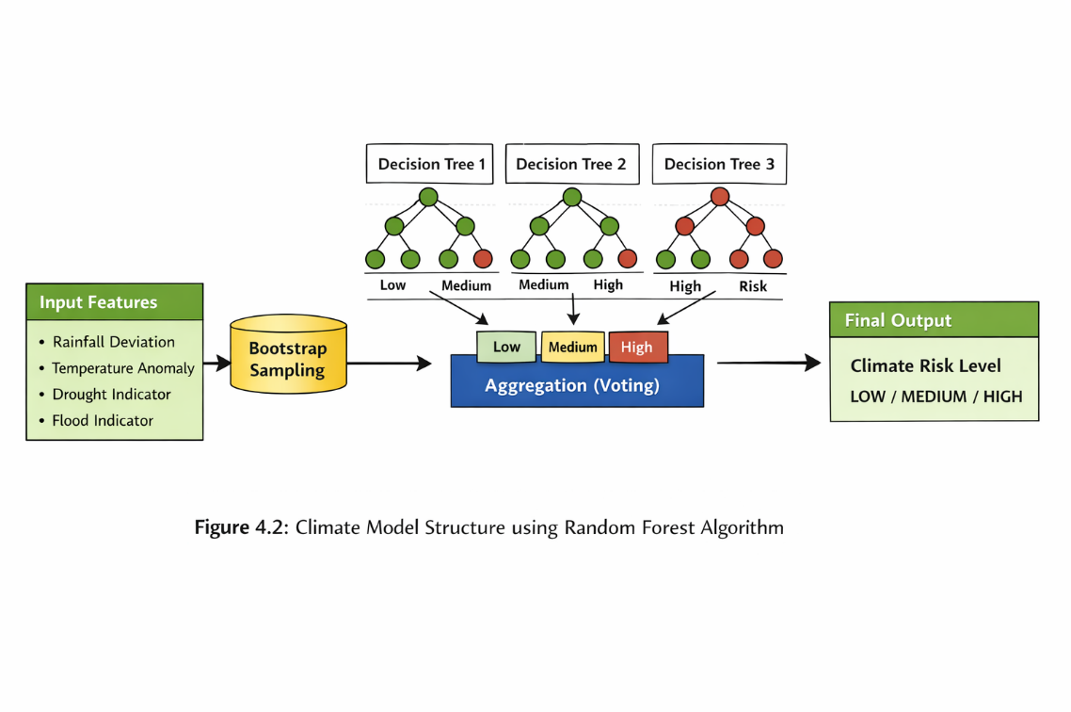

Figure 4.2: Climate Model Structure

4.3 Economic Assessment Model (Ridge Classifier)
The Economic Assessment Model uses Ridge Classifier, which applies L2 regularization to improve model performance. It is suitable for datasets with correlated features.
The model evaluates financial indicators and classifies farmers based on economic distress levels.

Feature | Description
Annual Income | Farmer income
Land Size | Area of land
Loss Percentage | Crop damage
Loan Amount | Financial burden
Table 4.2: Economic Model Features

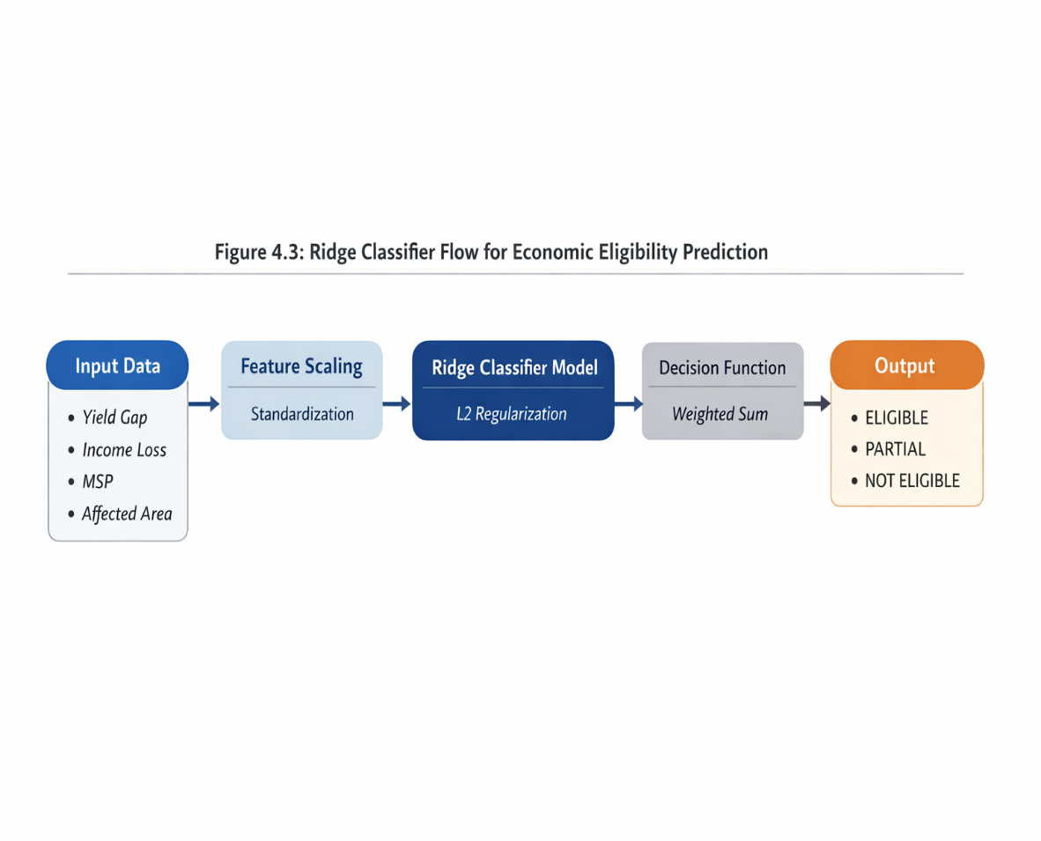
Figure 4.3: Ridge Classifier Flow

4.4 Welfare Priority Model with SHAP
The Welfare Model uses Random Forest along with SHAP to provide explainable predictions. SHAP values indicate the contribution of each feature toward the final output.
For example:
- Low income → Positive contribution
- High loss → Strong positive contribution
- Large land → Negative contribution
This helps officers understand the reasoning behind each decision.

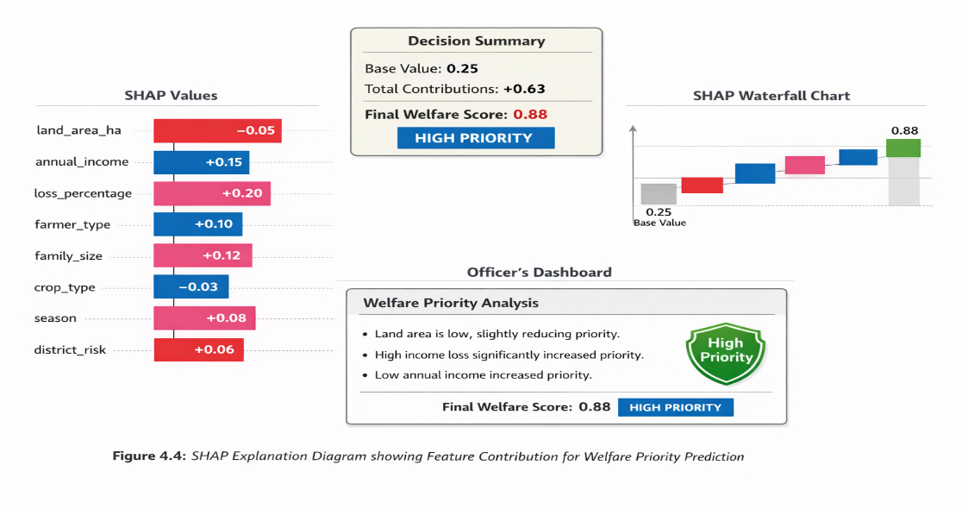

Figure 4.4: SHAP Explanation Diagram

4.5 Rule-Based Decision Engine
The final decision is generated using a rule-based engine that ensures consistency and compliance with government policies.

Decision Logic
- If Policy Agent → NOT ELIGIBLE → REJECT
- If Legal Agent → NOT VERIFIED → REJECT
- If Climate Risk → LOW → REVIEW
- If Welfare Priority → HIGH/CRITICAL → APPROVE
- Otherwise → REVIEW
This hybrid approach ensures that decisions are both intelligent and reliable.
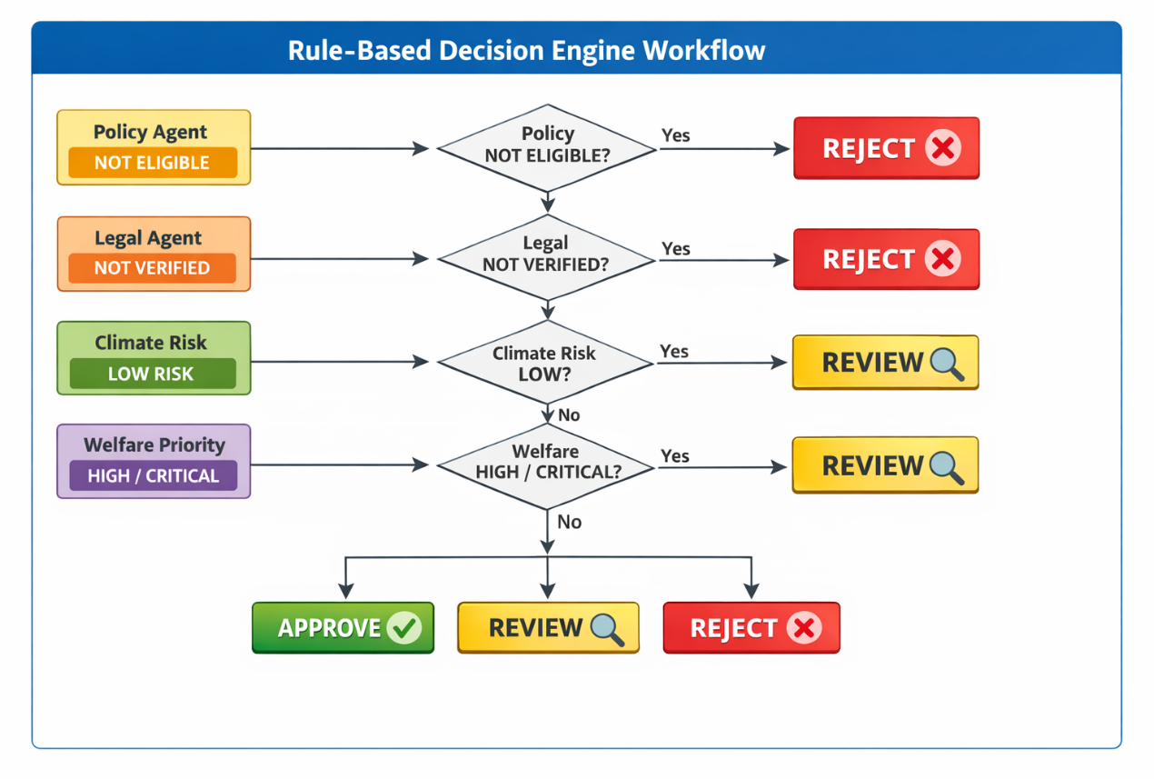
Figure 4.5: Decision Engine Workflow

4.6 Weather API Integration
The system integrates external weather APIs to validate climate conditions. This allows real-time verification of disaster events.
The API provides:
- Rainfall data
- Temperature data
- Wind speed
This enhances accuracy in climate validation.

4.7 GPS Verification Service
The GPS verification module ensures that the farmer’s claimed land location matches their actual location. It uses geolocation data from the device and calculates distance using mathematical formulas.
Verification categories include:
- Verified
- Near Match
- Mismatch

4.8 Document OCR Service
The OCR module extracts information from uploaded documents such as ID proofs and land records. It uses pattern matching techniques to identify relevant fields

4.9 Insurance Calculator
The insurance calculator computes compensation based on government schemes. It uses parameters such as land area, crop type, and season to determine the amount.

CHAPTER 5
IMPLEMENTATION

5.1 Development Setup
The implementation of the Agentic AI Decision Support System is carried out using a modern and lightweight technology stack that supports rapid development and efficient execution. The system is developed using Python as the primary programming language due to its extensive support for machine learning, web frameworks, and data processing.
The backend is implemented using FastAPI, which provides high-performance RESTful API development and seamless integration with machine learning models. The frontend is developed using HTML, CSS, and JavaScript to create a responsive and user-friendly interface for both farmers and government officers.
The development environment includes the installation of required libraries such as scikit-learn for machine learning models, SHAP for explainable AI, and SQLite for database management. The system is tested locally using a development server before deployment.
The overall project structure is organized into separate modules for better maintainability and scalability.

Project Structure:
Agri_Agentic_AI/
├── src/
│ ├── api.py # FastAPI application (main entry)
│ ├── storage.py # SQLite database operations
│ ├── crewai_setup.py # OpenAI API key configuration
│ ├── main.py # CLI entry point
│ ├── agents/ # Multi-agent AI framework
│ │ ├── __init__.py
│ │ ├── base_agent.py # Abstract agent base class
│ │ ├── crewai_orchestrator.py # Agent coordinator
│ │ ├── policy_agent.py # Scheme eligibility agent
│ │ ├── legal_agent.py # Land verification agent
│ │ ├── climate_agent.py # Weather/disaster agent
│ │ ├── agri_economic_agent.py # Subsidy calculation
│ │ └── welfare_agent.py # Priority scoring
│ └── utils/
│ ├── __init__.py
│ ├── data_loader.py # CSV/JSON loading
│ ├── model_loader.py # ML model loading
│ ├── weather_service.py # Open-Meteo API client
│ ├── gps_verifier.py # GPS distance/area
│ ├── document_ocr.py # Document extraction
│ └── insurance_calculator.py # PMFBY calculator
├── frontend/
│ ├── farmer_portal.html # Main farmer interface
│ ├── officer_dashboard.html # Officer review interface
│ ├── track_application.html # Status tracking
│ ├── farmer_history.html # Application history
│ ├── analytics.html # Reports and charts
│ └── login.html # Authentication
├── dataset/
│ ├── POLICY RULE/
│ │ └── agriculture_schemes.csv # 353 schemes
│ ├── LEGAL AGENT/
│ │ └── land_verification.json # Land records
│ ├── CLIMATE AGENT/
│ │ └── climate_disasters.json # Disaster data
│ └── ECONOMIC AGENT models/
│ ├── best_ridge_model.pkl # Ridge Classifier
│ ├── scaler.pkl # StandardScaler
│ └── agri_economic.csv # Training data
└── docs/
├── TABLE_OF_CONTENTS_AND_CHAPTERS.md
└── PROJECT_REPORT.md

5.2 Backend Implementation
The backend is responsible for handling all core functionalities, including data processing, agent execution, and decision-making. FastAPI is used to create RESTful APIs that allow communication between the frontend and backend.
When a farmer submits an application, the data is received in JSON format and processed through the AI agent pipeline. Each agent performs its task and returns structured output, which is then passed to the decision engine.
Sample API Implementation
@app.post("/submit_application")
def submit_application(data: dict):
app_id = generate_id()

# Process through agents
policy = policy_agent(data)
legal = legal_agent(data)
climate = climate_agent(data)
economic = economic_agent(data)
welfare = welfare_agent(data)
decision = decision_engine(policy, legal, climate, economic, welfare)
return {"application_id": app_id, "decision": decision}

The backend ensures smooth orchestration of agents and efficient handling of requests

5.3 Frontend Implementation
The frontend consists of two main interfaces:

1. Farmer Portal
The farmer portal allows users to submit applications easily. It includes form fields for entering personal details, land information, crop details, and loss information. The interface is designed to be simple and accessible for rural users.
Key features include:
- Form-based application submission
- Multi-language support
- GPS location capture
- Application status tracking

2. Officer Dashboard
The officer dashboard provides a comprehensive view of all applications and AI-generated recommendations. It enables officers to review, approve, or reject applications.
Features include:
- Application summary display
- AI decision explanation
- Approve/Reject buttons
- Audit logs

Figure 5.1: Farmer Portal Interface

Figure 5.2: Officer Dashboard Interface

5.4 Multi-Language Support
To improve accessibility, the system supports multiple languages such as English, Tamil, Hindi, and Malayalam. This is implemented using a translation dictionary in the frontend.
The language selection feature allows users to switch between languages dynamically, making the system more inclusive for rural farmers.
This feature enhances usability and ensures that language barriers do not prevent farmers from accessing government services.

5.5 Model Integration
Machine learning models are integrated into the backend to perform prediction tasks. The trained models are saved as serialized files and loaded during runtime.
Model Loading Example
import joblib
model = joblib.load("model.pkl")
The input data is preprocessed and passed to the model for prediction. The output is then used by the system to make decisions.

SHAP Integration
SHAP is used to generate explanations for model predictions:
import shap

explainer = shap.TreeExplainer(model)
shap_values = explainer.shap_values(input_data)

5.6 Insurance Calculato

The insurance calculator module computes compensation based on government schemes. It uses parameters such as land area, crop type, and season.
Formula Used
Sum Insured = Land Area × Crop Rate
Premium = Sum Insured × Rate
This module provides quick financial estimates to farmers.

5.7 GPS Verification Module
The GPS module verifies the farmer’s location using geolocation services. The system calculates the distance between the claimed land location and actual coordinates.
Logic
If distance < threshold → Verified
Else → Review
This ensures authenticity of land claims.

5.8 Authentication System
The system implements a secure authentication mechanism for officers. Users must log in using credentials, and access is controlled using tokens.
Security measures include:
- Password hashing
- Token-based authentication
- Role-based access control

5.9 System Workflow Execution
The complete workflow of the system is executed as follows:
- Farmer submits application
- Data is sent to backend
- Agents process data sequentially
- Decision engine generates output
- Result is stored in database
- Officer reviews application
- Final decision is updated

Figure 5.3: Final Decision Workflow
(Draw flow diagram)

5.10 Output Generation
The system generates structured output that includes all agent results and final decision.
Sample Output
{
"policy": "ELIGIBLE",
"legal": "VERIFIED",
"climate": "HIGH",
"economic": "HIGH",
"welfare": "CRITICAL",
"final_decision": "APPROVE"
}
This output is displayed in the officer dashboard along with explanations.
CHAPTER 6
TESTING AND RESULTS

6.1 Unit Testing
Unit testing is performed to verify the correctness of individual components of the system. Each module, including the AI agents, API endpoints, and utility services, is tested independently to ensure that it functions as expected. The objective of unit testing is to identify and fix errors at an early stage of development.
In this system, unit testing is applied to key components such as the Policy Agent, Legal Agent, Climate Agent, Economic Agent, and Welfare Agent. Each agent is tested with sample input data to validate its output against expected results. For example, the Policy Agent is tested to ensure that it correctly classifies applications as eligible or not eligible based on predefined criteria.
Additionally, API endpoints are tested using tools such as Postman to verify request handling and response generation. This ensures that the backend services operate reliably and return correct outputs.

6.2 Integration Testing
Integration testing is conducted to evaluate the interaction between different modules of the system. Since the proposed system follows a multi-agent architecture, it is essential to ensure that all agents work together seamlessly.
During this phase, the complete workflow is tested, starting from farmer application submission to final decision generation. Data flow between the frontend, backend, AI agents, and database is validated. The orchestrator is tested to confirm that it correctly coordinates agent execution and aggregates results.
Integration testing helps in identifying issues related to data inconsistency, communication failures, and incorrect sequencing of operations. The results indicate that the system successfully integrates all components and produces consistent outputs.

6.3 Performance Evaluation
Performance evaluation is carried out to measure the efficiency and responsiveness of the system. Key performance metrics include response time, processing time, and system throughput.
The results show that the system performs efficiently under normal conditions. The average response time for API requests is less than a few seconds, while the complete AI processing pipeline takes approximately 2 to 5 seconds per application.
The performance of individual modules is summarized below:
- API response time: Less than 1 second
- AI processing time: 2–5 seconds
- Database operations: Less than 100 milliseconds
These results demonstrate that the system is capable of handling real-time application processing with minimal delay.

Figure 6.1: System Performance Graph
(Insert graph showing response time vs operations)

6.4 Decision Analysis
Decision analysis evaluates the effectiveness and accuracy of the system in generating recommendations. The hybrid approach combining machine learning models and rule-based logic ensures that decisions are both data-driven and policy-compliant.
The system processes multiple factors such as eligibility, land verification, climate risk, economic condition, and welfare priority before generating a final recommendation. The use of SHAP explanations allows for better understanding of how each feature contributes to the decision.
The analysis shows that the system produces consistent and logical decisions across different test cases. High-risk and high-priority cases are correctly identified and recommended for approval, while invalid or ineligible applications are rejected.

6.5 Test Cases and Results
A set of test cases is designed to evaluate the functionality of the system under different scenarios. Each test case includes input conditions, expected output, and actual output.

Table 6.1: Test Cases and Results
Test Case | Description | Expected Result | Actual Result | Status
TC-01 | Application Submission | Success | Success | PASS
TC-02 | Policy Validation | Correct Eligibility | Correct | PASS
TC-03 | Land Verification | Verified | Verified | PASS
TC-04 | Climate Analysis | Risk Detected | Detected | PASS
TC-05 | Economic Assessment | Correct Output | Correct | PASS
TC-06 | Welfare Priority | Priority Assigned | Assigned | PASS
TC-07 | Final Decision | Accurate | Accurate | PASS

The results indicate that all modules are functioning correctly and meeting expected outcomes.

